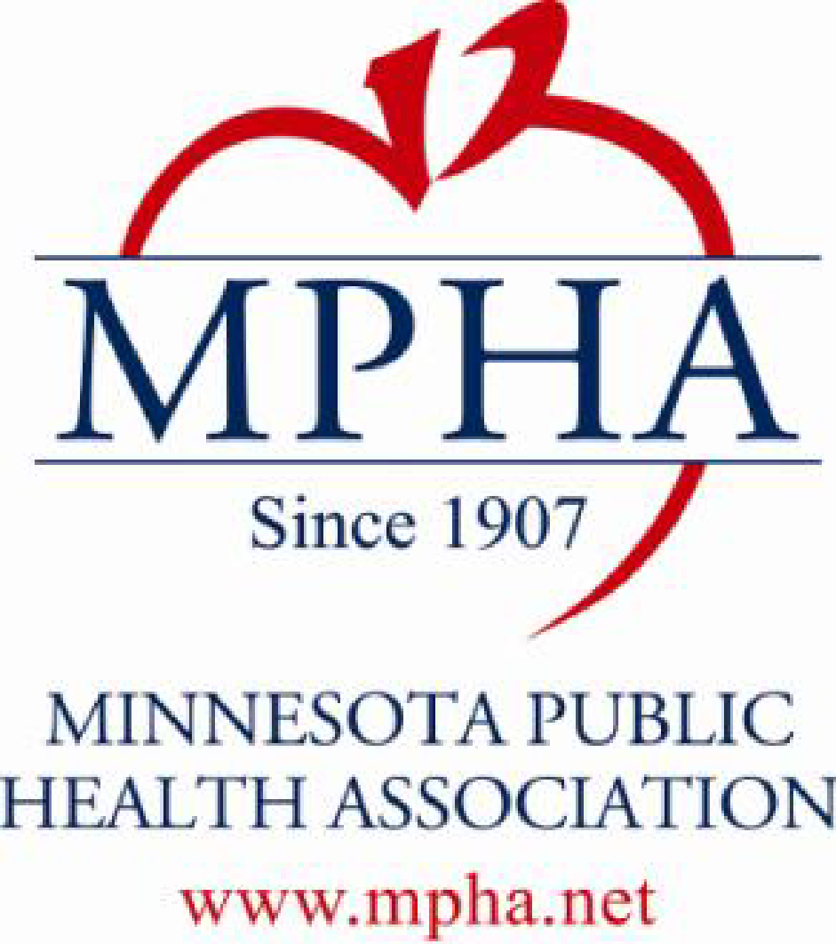

MINNESOTA PUBLIC HEALTH ASSOCIATION, INC.

PAUL & SHEILA WELLSTONE PUBLIC HEALTH ACHIEVEMENT AWARD

Background
The Paul & Sheila Wellstone Public Health Achievement Award is presented to a person who has distinguished themselves in public health through an outstanding contribution, which exemplifies MPHA's mission to promote and protect the health of individuals, families and the community. Additionally, the nominee should have either displayed leadership as demonstrated by the impact of his or her effort on the careers and accomplishments of other public health professionals, or have made a contribution that reflects innovation, creativity or a courageous pioneering effort consistent with professional excellence and public service. The award was renamed in 2003 in memory of the late Minnesota Senator Paul Wellstone, who served in the U.S. Senate from 1991 to 2002, and his wife Sheila Wellstone to recognize and honor the significant contributions they both made in promoting the health and well-being of all individuals.

Guidelines
Nominees:
- May or may not be a current or past member of MPHA.
- Should have made a contribution that exemplifies MPHA's mission to promote and protect the health of individuals, families and the community.
- Should have distinguished themselves in the field of public health.
- Should have made an outstanding contribution to the health of the public, and have:
- Displayed leadership as demonstrated by the impact of their effort on the careers and accomplishments of other public health professionals, or
- Made a contribution that reflects innovation, creativity or courageous pioneering effort consistent with professional excellence and public service.

Paul & Sheila Wellstone Public Health Achievement Recipients

(Formerly the MN Public Health Achievement Award)

1983 Michael Osterholm, Ph.D.
1984 Grace Gummit
1985 Robert Ten Bensel, M.D.
1986 Robert Veninga, Ph.D.
1987 Leonard Schuman, M.D.
1988 Barbara O'Grady
1989 Lee D. Stauffer
1990 Richard Raile, M.D.
1991 Ann Moorhous
1992 Jean Forster, Ph.D.
1993 Bob Hiller
1994 Beverly Propes
1995 Christopher Reif, M.D.
1996 Michael Moen
1997 Barbara Spradley
1998 George Bowlin
1999 LaVohn Josten
Barbara Leonard
2001 Jan Malcolm
2002 Aggie Leitheiser
2003 Buddy Ferguson
2004 Donna Anderson
2005 Steven Miles, M.D.
2006 Edward P. Ehlinger, M.D.
2007 Gretchen Musicant
2008 Lorene Wedeking
2009 Carol E. Berg
2010 Esther Tatley
2012 Linda Olson Keller, DNP
2013 Angeline Carlson
2014 Charles Oberg, M.D.
2015 James Harvie
2016 Melanie Peterson-Hickey, PhD
2017 Jaime Martinez
2018 Erica Fishman
2019 Lisa Dunlap
2020 CoCo Villaluz
2021 Jackie Dionne

